DIS Specification

# Components Diagram

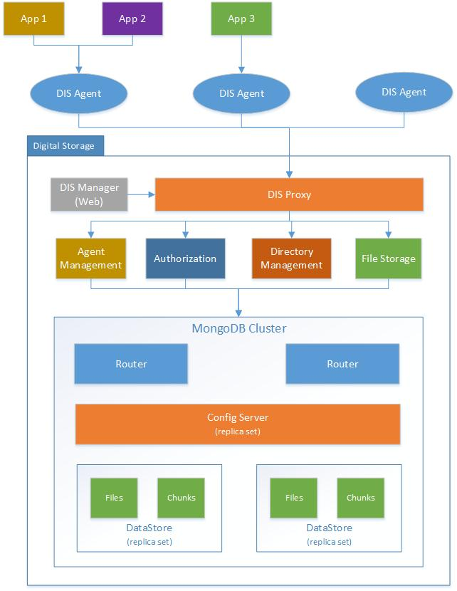

# Setup Configuration

Khi cài đặt DIS, hệ thống DIS tự động generate 2 cặp encryption keys (publickey + privatekey) phục vụ mã hóa dữ liệu:

* DIS Encryption Keys: Dùng khi gửi dữ liệu từ các Agent về DIS
* Agent Encryption Keys: Dùng khi gửi dữ liệu từ các AppClient về Agent. Có lựa chọn dùng hay ko dùng encryption khi config&run Agent.

Thông số cài đặt Agent: (dùng chung cho tất cả agent)

* DIS Key
* DIS public key (for encryption)
* DIS Proxy connection info (host+port/url)
* Agent private key

Thông số thiết lập cho AppClient:

* App Key
* Agent public key (được generate by Agent, gửi lên DIS qua request register)
* List Agent connection info (host+port/url)

# Https API

## Agent API: (AppClient -> Agent)

### File API:

* uploadFile(appKey, userName, fileContent, parentId, fileName)
* uploadFileWithPath(appKey, userName, filePath, parentId, fileName)
* fownloadFile(appKey, userName, fileId, fileName)
* getFileInfos(appKey, userName, fileIds)
* deleteFile(appKey, userName, fileId, parentId)
* shareFile(appKey, userName, fileId, permissions, emails)

### Directory API:

* createFolder(appKey, userName, folderName, parentId)
* moveFolder(appKey, userName, folderId, newParentId)
* renameFolder(appKey, userName, folderId, folderName)
* deleteFolder(appKey, userName, folderId)
* getFolderInfos(appKey, userName, folderIds)
* downloadFolder(appKey, userName, folderId, folderName)
* moveFile(appKey, userName, fileId, parentId, newParentId)
* shareFolder(appKey, userName, folderId, permissions, emails)

### Access Permission

* setPermission(appKey, userName, email, folderId, permissions)
* semoveUserAccess (appKey, userName, email, folderId)
* getUsersAccess(appKey, userName, folderId)

## DIS Proxy API: (Agent -> DIS)

### Agent API:

* + registerAgent(agentKey, agentInfo)
  + ping(agentKey)

### File API:

* + addFileInfo(agentKey, appKey, userName, fileInfo)
* addChunk(agentKey, appKey, userName, chunkInfo)
* finishUpload(agentKey, appKey, userName, fileId)
* getFileInfos(agentKey, appKey, userName, fileId)
* getChunk(agentKey, appKey, userName, fileId, chunkNumber)
* deleteFile(agentKey, appKey, userName, fileId)
* shareFile(agentKey, appKey, userName, fileId, permissions, emails, fileName)

### Directory API:

* createFolder(agentKey, appKey, userName, folderName, parentId)
* moveFolder(agentKey, appKey, userName, folderId, newParentId)
* renameFolder(agentKey, appKey, userName, folderId, folderName)
* deleteFolder(agentKey, appKey, userName, folderId)
* getFolderInfos(agentKey, appKey, userName, folderIds)
* moveFile(agentKey, appKey, userName, fileId, parentId, newFolderId)
* shareFolder(agentKey, appKey, userName, folderId, permissions, emails)

### Access Permission

* setPermission(agentKey, appKey, userName, itemId, itemType, email, permissions)
* getUsersAccess(agentKey, appKey, userName, itemId, type)
* removeUserAccess (agentKey, appKey, userName, itemId, email, typeItem)

# UserCase Diagram

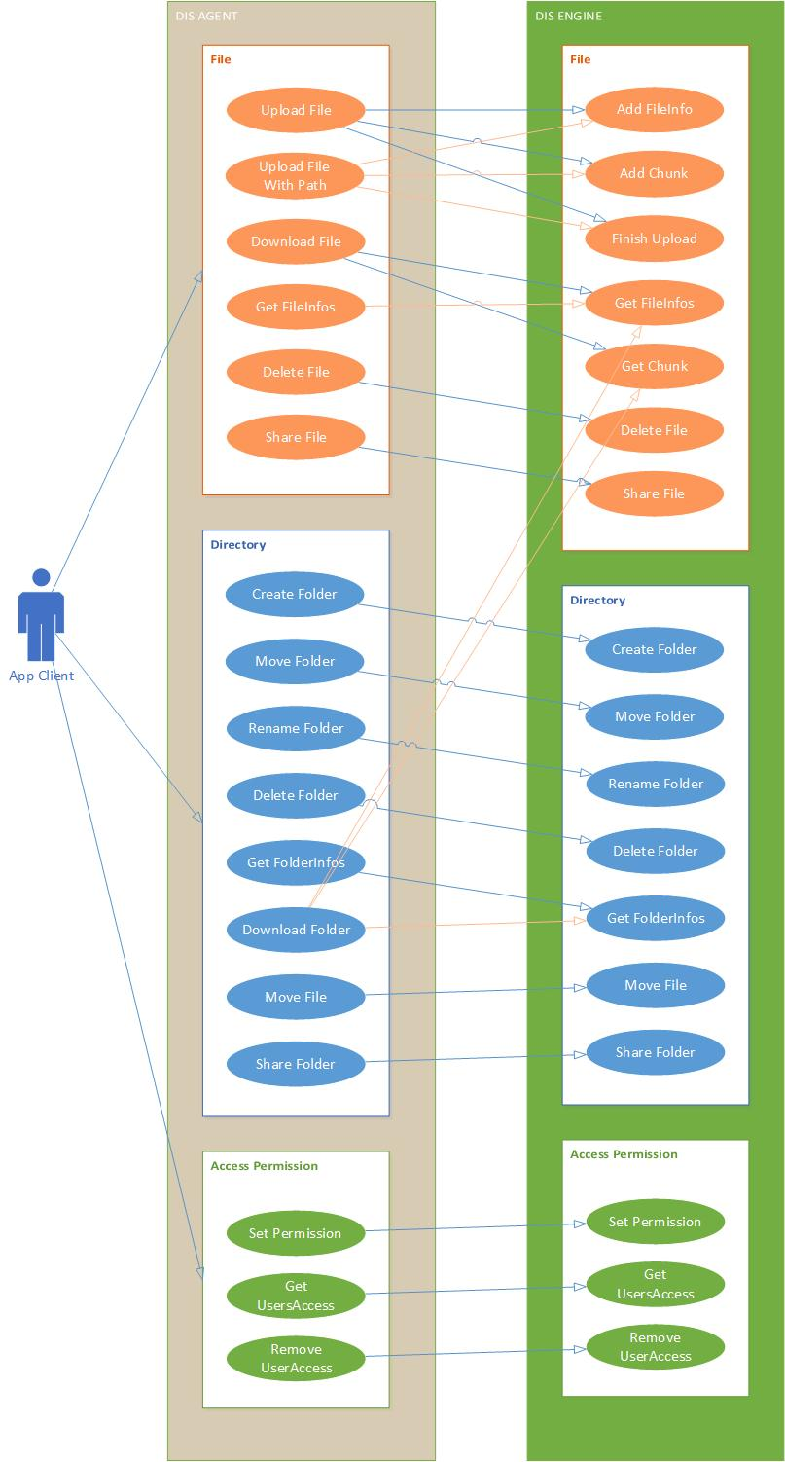

# Sequence Diagram